Application Guide: Biodiversity Fund 2026
Contents
Application Guide: Biodiversity Fund 2026 1
Section 1: Accessing the Grants Portal 2
Section 2: Applying via the Grants Portal 4
Section 3: Navigating the application form 4
Section 4: The application form questions 6
Section 5: FAQs 12

Section 1: Accessing the Grants Portal
All applications for funding must be submitted through the Grants Portal. Any applications that are submitted via email or through the post will not be accepted for funding.
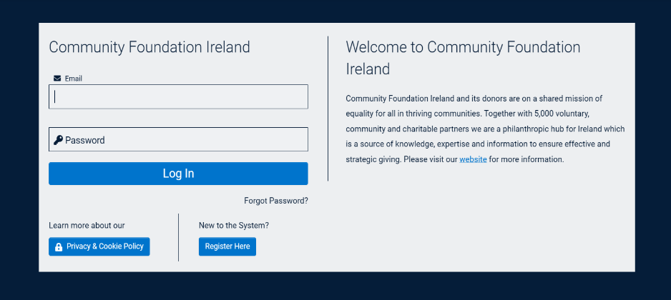
In order to submit your application, you must log in to our new Grants Portal.

Logging in
If you have applied to Community Foundation Ireland for funding in the past on behalf of your current organisation, you may already be in our system. You will be invited to ‘Forget your Password’ and then log in with your new details.
When you log in, you will be able to see all of the previous applications submitted by your organisation and opportunities to apply for funding.

Registering for the first time
If you have never applied for funding before, or you have recently joined your organisation, you may need to register an account to access your Grantee Portal. Click ‘Register Here’ to go through the registration process.
When you register, you will be asked to search for your organisation. You can use the organisation’s name, Charity Number or Company Number to see if it is already on our system.
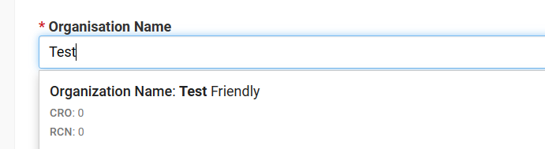

If your organisation already exists, you can submit your contact details. Once your account is approved, you can log in and access the opportunities to apply for funding.
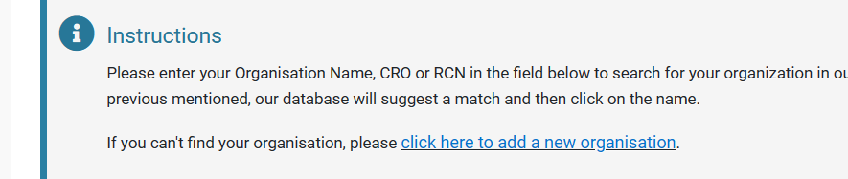
If you don’t see your organisation listed, you will need to add a new organisation and fill in the basic information.

Submitting your governance information and documentation
Before applying for funding, you will need you update your User Profile and Organisations’ Profile. If we do not have up-to-date information for your User and Organisation Profile, this will impact your ability to receive funding from the Foundation.
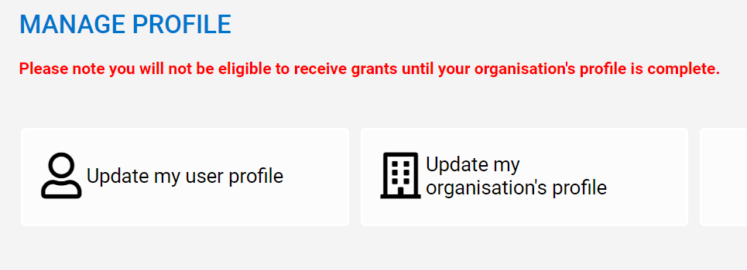
Please note, there are a number of Tabs to complete information about your User and your Organisation. Please make sure you have answered all of the required questions on each of the Tabs.
It will look like this:
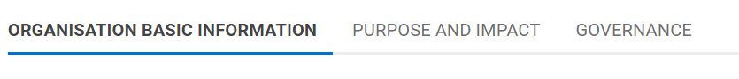
Via the ‘Governance’ tab, each organisation will be required to submit Governance Documents. These include:
- A governing document such as a mission statement, constitution, or memorandum and articles of association.
- List of committee/board/trustee members. This includes the length of time serving on the board/committee.
- Signed financial accounts or Income & Expenditure for the most recent financial year. For organisations with an annual income of €100,000 or more, accounts must be audited and signed by the auditors.
- Bank statement header that includes your organisation’s name, BIC and IBAN. We do not need to see any of the transactions.
- Certificate of Incorporation, if your organisation is constituted as a company.
Please make sure you have these documents ready and submitted before you apply for funding. Missing or incorrect documentation will impact your ability to receive funding.
Remember to click ‘Submit’ once all the information is uploaded.
Keep in mind that your organisation’s registration may take 24 hours to be approved, so please ensure that you give yourself enough time to register and fill out the application form.

Section 2: Applying via the Grants Portal
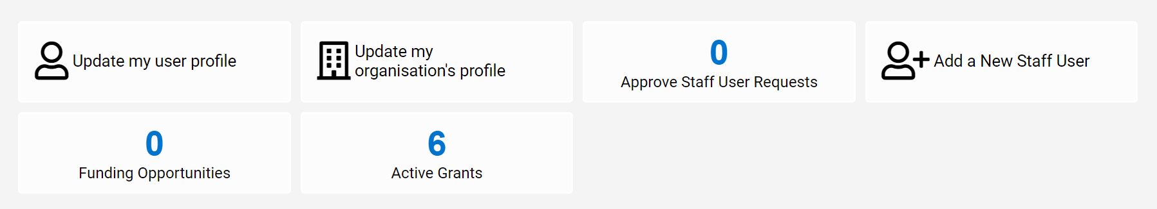

Once you have submitted your organisation’s information and governance documents, you can start your application to the grant round. On the Grants Portal homepage, you will see the Funding Opportunities available to you.

You will see a full list of the grant rounds that you can apply to. Click on the relevant grant round to read the criteria and apply for funding. Please ensure you have read the criteria document before applying to the grant round.
Click ‘Apply Now’ to access the application form.

Section 3: Navigating the application form
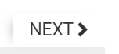
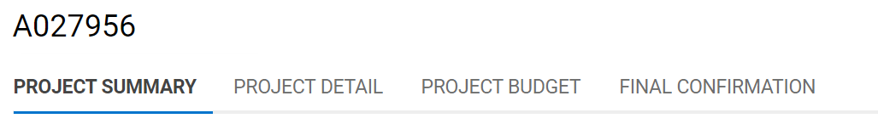
There are a number of different sections to the application form, please remember to click through all of the tabs before submitting your application. You can also click ‘Next’ at the bottom right-hand side of the screen.
Project Summary: This is where you will input the basic information about the project such as main contact details associated with the proposal, and the project demographics, issues and location. These pieces of information help us to measure our impact so please choose the options from the drop-down lists that suit your project the most.

Project Detail: This is where the main questions about your project are listed, such as the need for the project, the activities that will take place, and the impact of the project. We have outlined below some tips, tricks and advice for completing the application form. So make sure you read through this as you prepare your answers.

Project Budget: You can add in the information about your project budget in this tab. We also ask questions about the financial capacity and capabilities of your organisation to manage the funds if you are successful in your application. This is your opportunity to show us that you have policies, procedures and experience to manage the funds and the project.

Final Confirmation: Provide your consent here for us to contact you in relation to opportunities with our donors. Your answers here do not impact your likelihood of receiving funding. And finally, upload any documents that are requested of you for this application. Unless you have the correct documents, you won’t be able to receive funding.

Section 4: The application form questions
This may help if you wish to draft your application offline, however applications must be submitted via Community Foundation Ireland’s online portal. Emailed applications will not be accepted.
Please note: Word limits in brackets below are maximum word limits – not targets!

Project Summary
- Who is the secondary contact for this grant? (optional)
- What type of support are you applying for? (Select from drop-down menu)
- Please describe your project in one sentence. This should be a clear summary of your proposed project that will be used in publications to describe your work, should your grant be successful.
- Project start date
- Project end date

Project Beneficiaries
- Gender (Choose the most relevant option from: Men/Boys; Women/Girls; Non-binary; Transgender; All or N/A)
- Primary Age Group (Choose the most relevant option from: Children and Young People 0-18; Adults 19-55; Older People 55+; All pr N/A)
- Secondary Age Groups (optional)
- Primary Beneficiaries (Select General Public – unless you have a specific demographic)
- Secondary Beneficiaries (optional)

Project Issue Areas
- Primary Issue (Select from drop-down menu)
- Secondary Issues (Select others from the list if applicable)
- UN Sustainable Development Goals (Select which UN SDG your proposal aligns with)
- Secondary Sustainable Development Goals (Optional)

Project Geographic Reach
- Which is the primary county where this work will take place?
- Please select all the other counties where this work will take place. (optional)
- If relevant, does your organisation work in a specific type of community? (Choose from Rural, Urban, Town or N/A)

Project Type
- My project addresses the problem through: (Select from drop-down)
- The funding will support: (Select from drop-down)

Banking information
- Bank Name
- Bank Address
- Bank Account Name
- Bank Account Number
- Sort Code
- BIC/SWIFT
- IBAN
- Additional Details (text box for any notes if relevant)

Project Detail – New tab
In this section, you will provide more detail on your project. Share with us the problem faced, the solution your proposal will provide and how you will enact the solution.

- What is the need for this project? Why is this project needed specifically? (200 words)
- Describe your project/programme. Provide some information about your project that shows its value. (200 words)
- What are you hoping to achieve with your project? What are the three main aims or objectives? (200 words)
- Please outline how you will successfully engage the wider community in your project. (150 words)

Single Year Grant Quarterly Timeline and Activities
- Fill out a table in the portal as follows. One sentence is sufficient per quarter.
Quarter | Start date (month) | End date (month) | Activities
Q1
Q2
Q3
Q4

Unique Value
Show us why it is so important for your project to receive funding. You can use this section to share the unique or innovative elements to your project.

- Why is your organisation best placed to lead project? Show us why your organisation specifically can manage this project. You can include things like your expertise, experience or networks. (100 words)
- Are you working with other organisations on this project? (Yes or No)
- If yes, how many organisations are you working with on this project? (number only)
- If yes, provide details of the organisation(s) you are working with and the nature of the partnership. (100 words)

Project Impact
This section will show us the potential impact of your project, whether this is for the intended beneficiaries, the wider community, your organisation or on cultures, attitudes or systems.

- What is the estimated total number of direct beneficiaries? This should be the total number of people actively involved in the project. (number only)
- What is the estimated total number of indirect beneficiaries? This should be the number of people benefiting from the work undertaken – attending events for example. (number only)
- How many staff members will be involved in this project? (number only)
- How many volunteers will be involved in this project? (number only)
- What will be the direct impact of this project/programme on your beneficiaries? This should include detail on what your group hopes to gain from this project. (100 words)
- What is the impact of this project on the local environment? Highlight how this project will benefit your local environment. (100 words)
- Describe the intended impact of this project on the indirect beneficiaries. Describe the wider impact of your project on the community in your area. (100 words)
- How will you monitor and measure the impact of your project? For example, how will you get feedback from the community on your work, for example (100 words)

Project Budget – New tab
- What is the total cost of the project? Provide a total cost for the project even if that exceeds the amount requested. (whole number only)
- How much money are you applying to us for? (whole number only)
- How much if any has been raised so far? (whole number only)
- Details of funding raised so far. If you are not asking us to fund the full costs, how much have you raised already? (100 words)

Budget Table
- Fill out a table in the portal as follows. E.g:
Budget Item (Drop-down options) | Budget Detail | Year 1 Costs
Project/Programme delivery costs | Ecologist fee | 5,000
Publicity/Communications Costs | Launching our CBAP in the community hall | 1,000

The Budget Item column is a drop-down menu. You must choose between: Project/Programme delivery costs; Staff salaries and associated costs; Capital costs; Research costs; Advocacy/Lobbying costs; Publicity/Communications costs; Organisational Capacity Building costs; Other Overhead costs; Contingency costs

One line for budget details is sufficient.

Financial Management
- If the total cost exceeds amount requested, plus any funds raised so far, how will the remaining gap be funded? (100 words)
- What will happen when this funding ends? Will the work be sustained by other funding? If yes, how will you raise these funds. If not, how will your organisation manage the wind down of the project? (100 words)
- Please demonstrate how your organisation has the financial capacity and capabilities to manage a grant of this size. You may also refer to past experience of managing funds of a similar amount. (100 words)

Budget Checklist
- Will you be hiring a new staff member as a part of this project? Yes or No.
- If yes, please confirm that you have an up-to-date Equal Opportunities Policy in place that is in line with the Employment Equality Acts 1998 - 2015 and the Equal Status Acts 2000 - 2018.
- Will you be working directly with children 0-18 as part of this project?
- If yes, please confirm the following (Tick Yes or No):
  - That your organisation has a safeguarding statement or policy in place.
  - That this document is reviewed annually and follows best practice as outlined by the Charities Regulator and Statutory Bodies.
  - That your organisation is compliant with the Children First National Guidance for the Protection and Welfare of Children 2017 and Children First Act 2015.
  - If your organisation is based outside of Ireland, please confirm that your organisation's procedures/practices are aligned with legal requirements/best practice in your country.
  - If the above is not in place, please explain why (100 words)
- Will you be working directly with vulnerable adults as part of this project?
- If yes, please confirm the following (Tick Yes or No):
  - That your organisation has a safeguarding statement or policy in place.
  - That this document is reviewed annually and follows best practice as outlined by the Charities Regulator, Statutory Bodies and Safeguarding Ireland.
  - That your organisation is compliant with the proposed Adult Safeguarding Bill 2017.
  - If your organisation is based outside of Ireland, please confirm that your organisation's procedures/practices are aligned with legal requirements/best practice in your country.
  - If the above is not in place, please explain why (100 words)
- Does your project include larger scale capital/building work (where the cost of the work totals more than €20,000)? (Tick Yes or No)

Final Confirmation
- Would you be able to host a site visit from the donor to see the impact of your work? (Tick Yes or No)
- Would it be appropriate for a donor to speak to some of the beneficiaries of this project to learn more about the impact of their funding? (Tick Yes or No)
- How did you hear about this grant round? (10 words)
- If successful, please confirm whether Community Foundation Ireland can share your contact details with the funder to share information in relation to this grant round. (Tick Yes or No)
- If we are not able to fund you through this grant round, please indicate whether you would like us to share this proposal and contact details with another potential funder. (Tick Yes or No)
- I confirm that the information given on the application form is true and my group has formally agreed that I can act on their behalf. (Tick Yes or No)

Documentation Upload
- Bank Statement (only if the bank account is different to that already submitted by your organisation)
- Please upload any other relevant documents (optional).

Section 5: FAQs
Please read through the following FAQs regarding the Biodiversity Fund. If your question is not answered, please email us at info@foundation.ie

What types of organisations can apply to the fund?
Any non-profit organisations working to achieve the objectives of the grant round can apply. Your organisation must have up to date and sufficient governing documents, and annual accounts.

My organisation is a local group which is part of a national network, can I apply?
Yes, and any other local group who is part of the national network can also apply.

My organisation is based in Northern Ireland, can I apply to this Fund?
No, this Fund is only available to organisations based in the Republic of Ireland. Community Foundation Northern Ireland may have funding opportunities you could be eligible for. Find out more here: https://communityfoundationni.org/

I do not have a CBAP, but I have a specialised ecological report for my area. Can I apply to Implement Recommendations from this report?
These will be dealt with on a case-by-case basis. Please contact info@foundation.ie before applying and send us the report.

I have a general biodiversity project that I would like to fund. Can I apply?
No. This Fund is specifically set up for developing Community Biodiversity Action Plans and implementing recommendations from these plans.

Can I send in my proposal via email or post?
No. All proposals must be submitted through our online application form.

Can I apply for a project that has already happened/started?
No. We cannot award funding for work that has already happened.

Can I apply for a project that costs more than the amount I can apply for?
Yes. Organisations doing so must show in their application how they will fund the gap.

My organisation received funding through a previous Biodiversity Fund round – Can I apply again?
Yes, provided you have submitted your CBAP to both us and the National Biodiversity Data Centre.

Does my organisation need a bank account?
Yes. We can only pay out grants to organisations with a dedicated bank account.

I am not able to submit my governance documents, what can I do?
We cannot accept applications without all the correct governance documents. If you are having trouble submitting the documents, email us at info@foundation.ie before the deadline, and we will be able to help you.
Please be mindful that if you are submitting last minute and are not able to submit your documents, we may not be able to help you before the round closes.

